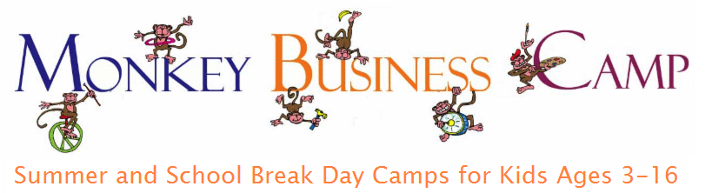

TILDEN OUTDOOR SUMMER PROGRAM
DAILY SCHEDULE CAMP THINGS TO BRING
**Please label all items sent to camp**

Reminder to pack light, but also bring necessary items. It makes a big difference when you bring the items requested. We are outside all day, so campers really need items like a water bottle & hat.

Camp Gear: Layers for the warm and cold, shoes for outdoor play, rain gear if looks like rain, watch (timepiece) for youth leaders. Reminder that camp is all about play and exploration, essential for human well-being. This often means clothes will get dirty

What to Bring in Backpack:
- water bottle-Please don’t forget this, since so important for staying hydrated.
- Hat-we will tell campers to wear when in the sun, but really could use your support, if that also important for you.
- lunch and morning snack, with all utensils.
Food Notes: Please no nuts or nut butters, as we have new campers each week. Need ideas for alternates? cheese, hard-boiled egg, hummus, yogurt, sunflower seed butter. If you forget lunch for any reason and cannot make it back to camp, we have nut free bars on site.
Snack packing: we recommend separating it in some way from lunch, so easy for your child to know difference between it and the lunch, for ex. A labeled bag in lunchbox (and tell your child about it).
- Medications:
  - Your medical form should list meds you will bring to camp.
  - We only take those on an “as needed” basis, not ones that are scheduled.
  - If you need to make any updates to your medical form, please e-mail: office@monkeybusinesscamp.com to unlock your form and do so by Thursday morning before camp.
Once at camp,
- give meds to site director the first morning, and we will store it in our first aid backpack.
- If you would like your child to carry their own meds (usually only for older kids who are able to track), please fill out this waiver and send to the office by Friday morning before camp.
- On your child’s last day, please remember to pick up any meds.

Do Not Bring: toys from home with exception of cards (Pokeman, Magic, e.g.) to play during “free play” times. Staff cannot fully control what happens, so consider if or what cards get sent.
Cell phones: if your child has one, make sure they turn off and leave in backpack for the day.

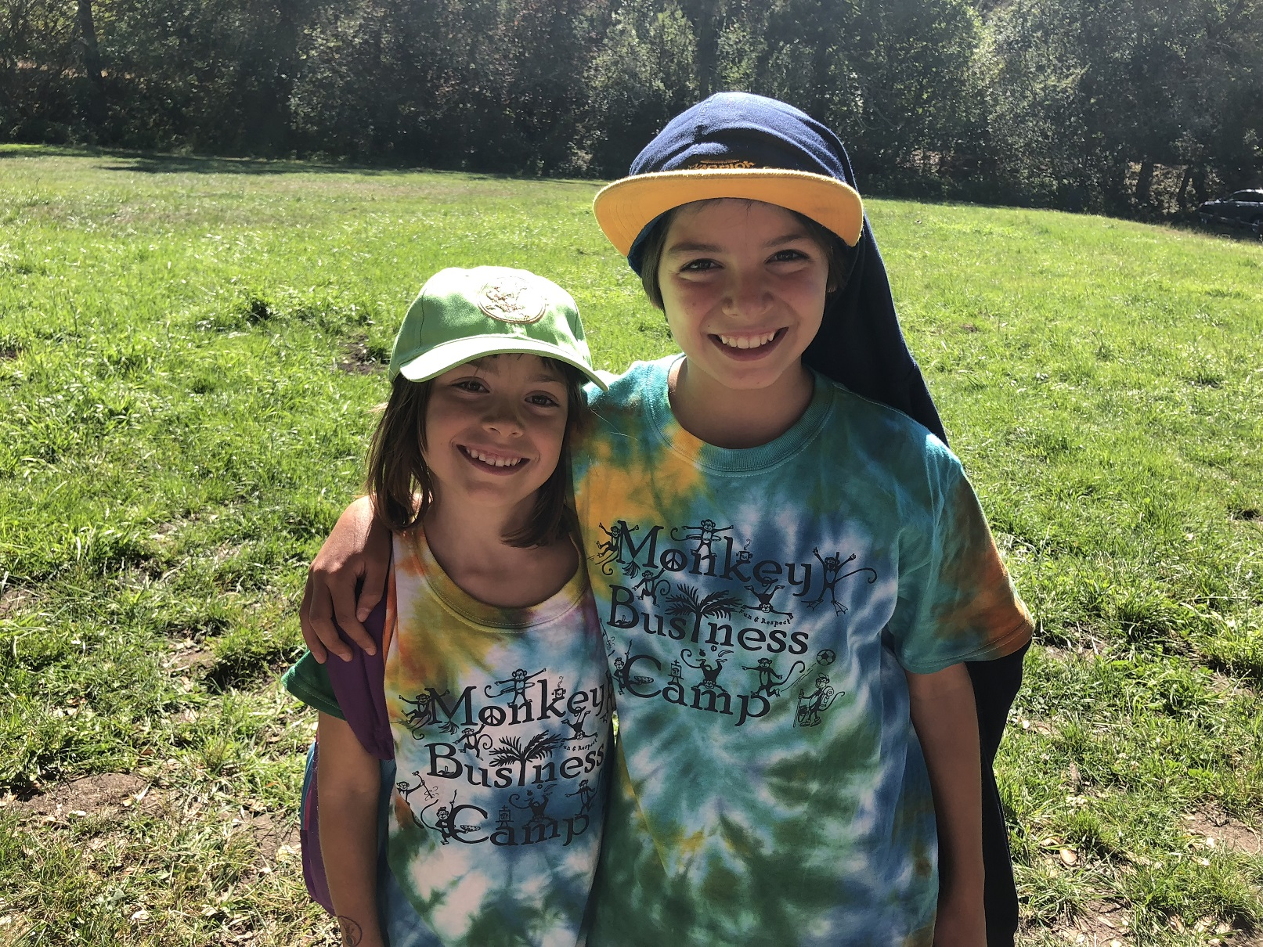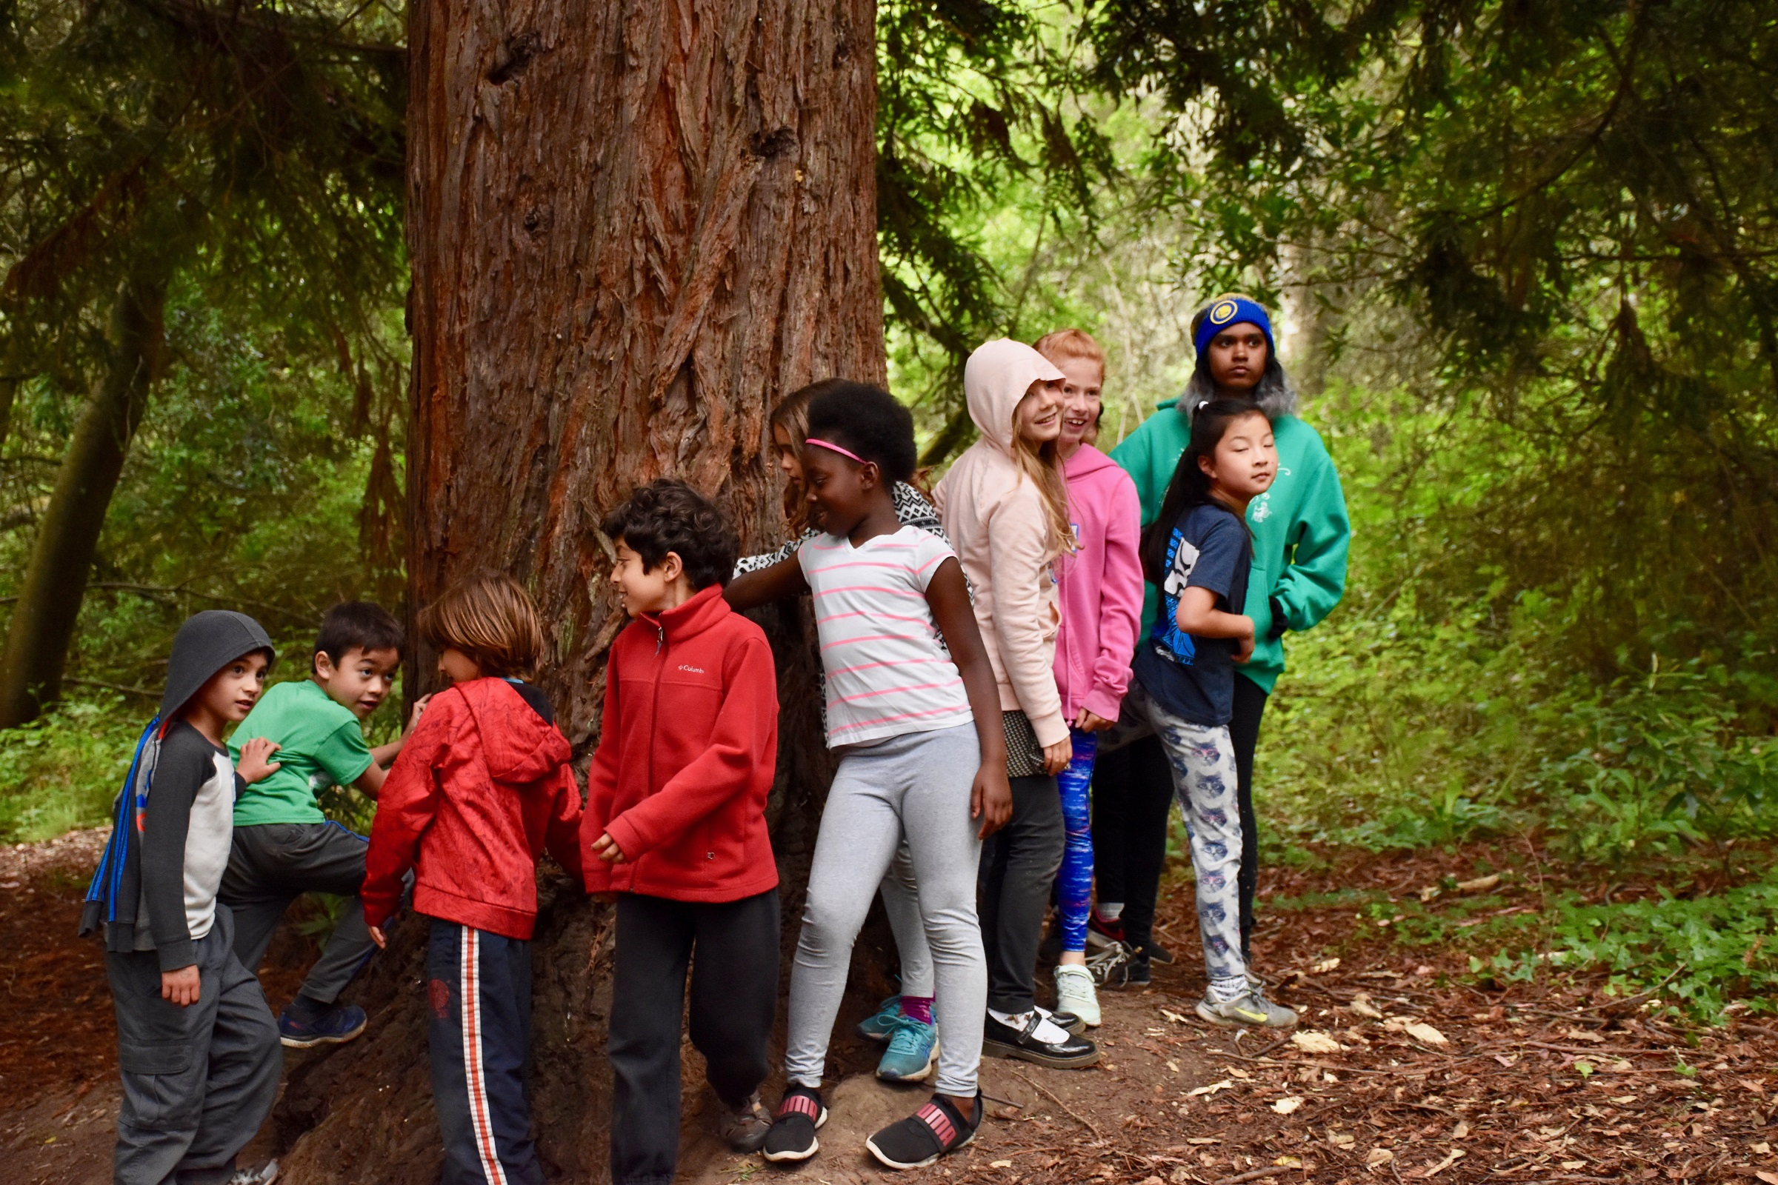

WACKY WEDNESAY AND SWIM DAY GEAR
***PLEASE LABEL ALL ITEMS SENT TO CAMP***

Wacky Wednesday fun. Wear anything wacky to camp, like funny hair, bright colors, backwards clothing, different socks, or a costume. Face painting and costumes will be site. Participation by choice!
All Thursdays are Swim Days (except last of summer, August 22): Play, splash and swim at Lake Anza
- Wear/bring bathing suit to camp. Since we swim at sun intensity times (around 12-2:30 period), please send your child in full body bathing suits, similar to this rash guard (search google for ideas if this link stops working!)
- Gear to pack into backpack: Make sure kids can carry their own backpack.
  - Towel
  - plastic bag for wet items
  - goggles (optional)
  - ice-pack for lunch, since packs in sun more today.
- Sun Protection on swim days: We are committed to keeping your child's exposure to the sun to a minimum. Here’s our plan and how you can help:
  - Send your child in the morning with sunblock on areas exposed to sun with their suit on.
  - Our staff will do final application when wearing swim suits only (at 12:30). We only swim from about 12:30-2:30.
  - Hats are the best! We get those on, whenever we can, within limits of swimming, etc. Please let your child know they need to wear it and listen when staff and youth leaders remind them.

*****We are grateful for you!*****

Thank you! By signing up for our camp, you support a women & LGBTQ-led, locally started, certified green business that has successfully hired diverse teams, gives its year-round team benefits, and is committed to building a fun, caring and just workplace.
Copyright of Monkey Business Camp, Inc.

